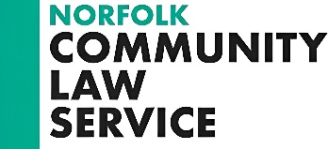

Trustee Application Form

Personal Details
Name
Address
 |  | Postcode
Email
Daytime telephone |  | Evening telephone

Employment Details – please give brief details of your previous employment (up to 5)
From | To | Title | Employer

Interest and Motivation: please tell us why you are interested in being a Trustee of Norfolk Community Law Service (up to 250 words)

Knowledge and Experience: Memberships, Board positions, Qualifications or other relevant experience as per Person Specification (up to 250)

Referees – please provide contact details of two referees
Name | Position | Organisation/ personal and email address

I confirm that the information on this form is correct to the best of my knowledge | Signature

Please send completed form to Sarah Clack: sarah@ncls.co.uk or Norfolk Community Law Service, 14 Prince of Wales Road, Norwich, NR1 1LB.

